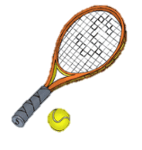
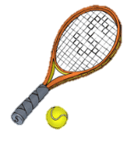
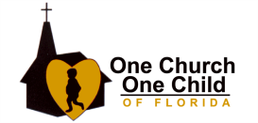
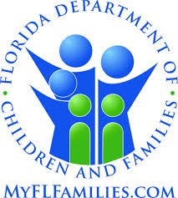
9th Annual Perfect Match Tennis Tournament

One Church One Child of Florida, Inc.

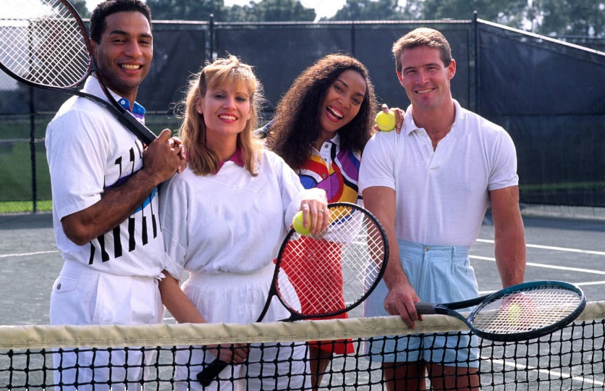
Tom Brown Park Tennis Courts

April 13, 2019

Support Kids in
Foster Care and Adoption

UP/DOWN Event for Players to participate with wheelchair players
Any level Welcome and fee is only $20 to participate

Singles, Doubles, Mixed Doubles
Start Time: Saturday, April 13, 2019, 8:00 a.m.
Early Registration by March 1, 2019: $25.00
Regular Registration Fee: $30.00 per Player/Event or
$30 for two or more Events

ONE CHURCH ONE CHILD 2019 PERFECT MATCH TENNIS TOURNAMENT

One Church One Child of Florida, Inc. is a statewide non-profit, child welfare organization working in partnership with the Department of Children and Families and Community Based Care Agencies to help ensure permanency for children in the state’s foster care system.
----------------------------------------------------------------------------------------------------------------------------------------------------------------------------------------------------------
STANDARD TOURNAMENT RULES:
- Play will begin Saturday, April 13, 2019 at 8:00 a.m.
- Please check in 15 minutes prior to your scheduled match.
- U.S.T.A. rules will govern play. Best two out of three sets. Third set 10 point tie breaker.
- Warm-up time will be limited to 5 minutes. There will be a 15-minute grace period before a match is defaulted.
- Draws: Starting times will be available April 10, 2019 on the Internet at http://www.ococfl.org. If you are unable to access your playing time via the Internet, call (850) 414-5620 between 8:00 a.m.-5:00 p.m.
----------------------------------------------------------------------------------------------------------------------------------------------------------------------------------------------------------
ENTRY FORM (Please Print All Information) Participants are limited to two events: one gender and one mixed doubles please

Name ___________________________________________________________________________________ Current USTA Rating _______________

Address __________________________________________________________________________________________________________________

City ____________________________________________________________ State______________________________ Zip ___________________

Phone _______________________________________________ E-mail ______________________________________________________________

(Circle Desired Event(s))
SINGLES 3.0, 4.0, 5.0, Open

MEN’S DOUBLES 6.0, 7.0, 8.0, 9.0 and above Partner ________________________________________________________________________

WOMEN’S DOUBLES 6.0, 7.0, 8.0, 9.0 and above Partner ________________________________________________________________________

MIXED DOUBLES 6.0, 7.0, 8.0, 9.0 and above Partner ___________________________________________________________________________

Check T-shirt Size: S____ M____ L____ XL____ XXL____

I hereby release One Church One Child of Florida, Inc., their sponsors, agents, and representatives from any liability in the event of injuries, accidents, losses and/or other misfortune that might occur during or after my participation in the tournament events, which I enter. Permission is granted to One Church One Child of Florida, Inc. to use my likeness in photos, video, etc. for the promotion and/or marketing of One Church One Child of Florida, Inc. activities.

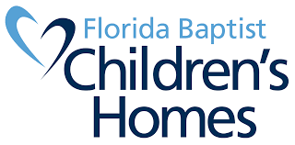
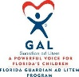
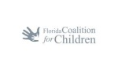
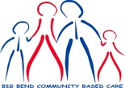
Signature of Player ________________________________________________________________ Date ____________________________________

Online Registration: @www.ococfl.org
MAIL IN REGISTRATION:
One Church One Child of FL • 3051 Highland Oaks Terrace, Suite 1 • Tallahassee, Florida 32301
(850) 414-5620 • Toll Free 1-888-283-0886

Make check payable to One Church One Child of Florida, Inc.

